SMART MOBILE APPLICATION FOR GIT COLLEGE BUS
College Bus Monitoring and Notification System

Pooja S Harugop
Department of Computer Science Engineering
Belagavi, India
poojaharugop@gmail.com
Varun Kulkarni
Department of Mechanical Engineering
Belagavi, India
varun16799@gmail.com

Abstract- This paper proposes an Android mobile phone application that gives information about buses, bus numbers as well as bus routes online through an App. This paper also deals with Location Based Services, which are used to track the current location of the bus as well as give an estimate remaining time for the tracked bus to reach its destination using the client –server technology. Also, it displays the required maps with the help of GPS. College bus app is easy to use by every student; as it tells the location of the bus such as the exact time it is supposed arrive.

Keywords- GPS, client-server Technology, Android studio Estimate time of arrival(ETA).

- Introduction
Android Mobile phones are the system which are been used by almost all the people in the Advanced Hi tech World. The mobile phone industry is one of the fastest and most dynamic business sectors today. Where as it is also the platform to this Fast Running World where it makes our life easy & convenient. The need to communicate efficiently and instantaneously is always an undying necessity. The market sector and the ever-growing and demanding consumers always want to have more, and they want it better than ever.
Communication is always a part of daily life, and we cannot avoid it. The invention of mobile phone has gone tremendous leaps in innovation and new applications. Originally, it was intended to be a telephone that can be carried wirelessly at greater distances. Advances in communications, upgrades in radio frequency and developments on the internet had given mobile phones more sophisticated but easy to use in applications. For instance, accurate map-matching algorithm for location tracking of a mobile.
Mobile phones are now equipped with navigation systems such as GPS or Global Position Satellite that aids students on getting the exact location of their college bus. Not only that, but this application may help students to get a notification of ETA (estimate time of arrival) to the location.
I also included the ID card scanning technology, which scans the ID card of the student who boards the bus, to check whether the student on board are all the students who paid for the transportation and other didn’t get on the bus

- Objective
The main objective of this app is to track LIVE location of the bus and timing of the bus as when it will arrive at the stop assigned by the drivers and the management of the College. It gives the ETA of the bus before arriving to the stop, just by sending a notification to each and every user according to their bus pickup point. This application also tells alternative bus routes to the students in case they miss the bus from that stop. It informs the drivers that how many students are present in the stop, so that bus never gets full. If many students are waiting near the bus stop and the bus is already full, then the driver has to notify it on the app using a signal which informs all the bus drivers near to that stop or location. Sometimes if there are no students on particular stop then the driver gets a notification as that no students waiting on this particular stop. Hence the driver can skip that location and reach college faster.
If a student is willing to go by bus then, only thing to be done is, when the student receives a notification of ETA he/she has to accept the pop up message arrived/displayed on their respective mobile phones. In this manner the driver will have an idea of number of students catching the bus.

- Android


Android is a free, open-source operating system for mobile devices. It is an open-source development platform for creating mobile applications. Devices, particularly mobile phones, run the Android operating system and the applications are created for it.
More specifically, Android is made up of several necessary and dependent parts, including the following:
- Linux operating system kernel that provides low-level interface with the hardware, memory management, and process control.
- Open-source libraries for application development, including SQLite, Web Kit, OpenGL, and a media manager.
- Software development kit used to create applications, including tools, plug-ins, and documentation.
- An application framework that agnostically exposes system services to the application layer, including the window manager and location manager, content providers, telephony, and sensors.
We create an app using Android Studio which is an open source development platform for creating various applications which are used in our day-to-day life.
Android Studio is the official integrated development environment (IDE) for Google's Android operating system, built on JetBrains' IntelliJ IDEA software and designed specifically for Android development. It is available for download on Windows, macOS and Linux based operating systems. It is a replacement for the Eclipse Android Development Tools (ADT) as the primary IDE for native Android application development.

- Methodologies

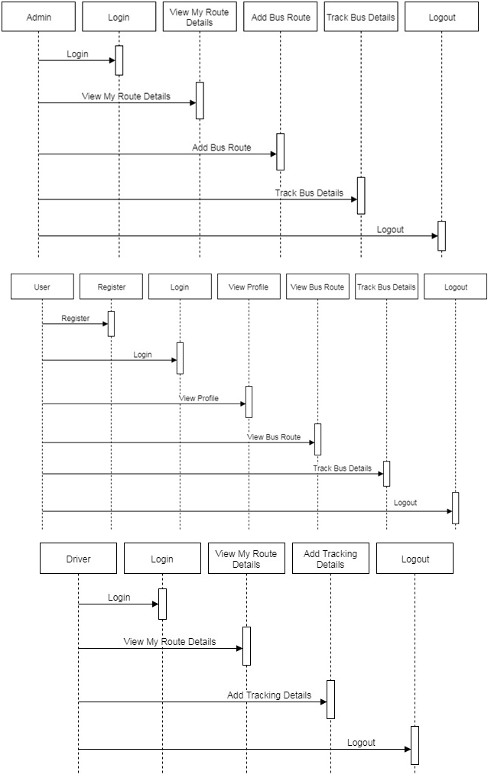

This application contains the three modules
- Admin
- User
- Driver

Admin:

Admin can login to the admin account after authentication and authorization. He can enter new route details and also he can select the route from the list of routes and then the corresponding stops are displayed. He has the options to add or remove a route. He also has the option to modify or remove a stop from the route. If admin want to say any information to the driver then he can send the message to the driver’s mobile via the app. He can also enter new student details and can view the list of students. He has the options to add or remove a student details. Admin has to update the timings of the bus regularly. If any changes are made by the management, then it’s the admin’s job to update it on the app, and inform each and every user by sending a notification.

- User:
User has to enter the USN given by the college to each and every student. As the details of the user will be already feeded into the system, the bus number for his/her destination will be displayed on the App. Using Google Maps the student can know the exact location of the bus. He can also receive an alert notification when the bus comes to the nearest stop only if he has enabled notifications.

- Driver:
Driver’s work in this application is just to drive the bus from stop to stop from source to destination. Only if there are no students on a particular stop then the driver gets a notification through which he can skip that stop. Drivers another work is to select ‘start’ option whenever he is headed to pick students. And ‘stop’ when he has dropped the students to their destination that is nothing but college. Notifying the bus is full is also the job of the driver, so that other bus drivers near to that location can pick the remaining students.

- Testing
Software testing is a process used for verifying the correctness, completeness and quality of the developed software. Software is built out of sub-systems that are composed of modules, which in turn are composed of procedures and functions. The sequence of testing activities performed for the tracking system is as below:
- Unit Testing
- Integration Testing
- System Testing
- Unit Testing :
There exist a number of components in every sub-system. Every component is tested using respective test procedures. Each component is tested individually based on their needs. Unit test focuses verification effort on the smallest unit of the software design component.

- Integration Testing :
Integration tests are designed to test integrated software components to determine if they actually run as one program.
- System Testing :
System testing is the stage of implementation. Testing is the process of executing a program with the intent of finding an error. A good test case is one that has a high probability of finding a yet undiscovered error.

- Advantages
The advantages of the system is as mentioned below:
- Since we can track the bus activity it makes us to converse more time and work efficiently.
- With the help of ETA we can get ready correctly on the days when we get up late and miss the timing we normally get ready.
- If we miss the bus in our stop we can check for the nearby bus station and its timing to arrive there accordingly

- Disadvantages
The following points are the disadvantages:

- The accuracy of the device is still be tested and it may cause problem accordingly to the service and device maintenance.
- The algorithm may cause change to the ETA on bases of bad climatic condition and other unavoidable road conditions.
- The route mentioned in the map may not be accurate accordingly to the road and bad climatic conditions.

- Future Enhancements
After analyzing the test results of the developed systems, the following issues are still open which can be taken up as future enhancements.
As Android phones are widely used everywhere, it is obvious that applications like these offer simple solutions to do our daily activities. These Android applications can be used in future to manage not only college buses but also the vehicles that belong to the institution. These applications can also be used in any other domain to carry out fleet management efficiently. Further we can also extend the app to manage traffic and report accident areas to the bus drivers, so that the driver can change the route immediately.

- Conclusion
In this project, we have presented an Android Application to track the college buses. The later development and the accuracy of the project depends on the development in both hardware and software.
In this project we try to save the time of the students mainly and some faculty who uses the college transportation service and we also tend to help them with easy and tension free mornings for a bright and peaceful day. We also intend to develop this project for school and public transportation services in the near future.

- Acknowledgement
It is indeed with a great pleasure and immense sense of gratitude that we acknowledge the help of these individuals. We are highly indebted to our Principal Digambar , KLS Gogte Institute of Technology, Belagavi for the facilities provided to accomplish this main project.
We would like to thank our Prof Rajpurohit, Head of the Department of Computer Science and Engineering, KLS Gogte Institute of Technology, Belagavi, for this constructive criticism throughout our project. They have been a constant source of inspiration for us and we are very deeply thankful to them for their support and valuable advice.
I thank my teachers and my fellow student who helped me complete this paper work in the required time. I also thank the college for standing by me throughout this process and help me in time of needs.

- References
- Jindan Zhu,1 Kyu-Han Kim,2 Prasant Mohapatra,1 and Paul Congdon2 “An Adaptive Privacy-Preserving Scheme for Location Tracking of a Mobile User” 2013 IEEE International Conference on sensing, Communication and networking.
- Referred Kantipur Engineering College’s “College bus tracking system” for writing this paper. Link:https://www.academia.edu/27965619/KANTIPUR_ENGINEERING_COLLEGE_College_Bus_Tracking_System_
- Mobile Application for College Bus Tracking G. Jemilda1 , R. Bala Krishnan2 , B. Johnson3 , G. Linga Sangeeth4 1 Faculty in CSE Department, JACSI College of Engineering, Tamil Nadu, India. UG Scholar in CSE Department , JACSI College of Engineering, Tamil Nadu, India.
- Real Time College Bus Monitoring and Notification System M. S. Minu, Deepak Adithya K. N.
- Bus Monitoring System using Android Application Suraj Phadatare1, Prathamesh Kudtarkar2, Jignesh Seth3, Asst. Prof. Vaishali Yeole4

